Experiment 09: CASE STUDY
EDGE COMPUTING AND FOG COMPUTING
A Smart Manufacturing / Industrial IoT Case Study

1. Abstract
Edge computing and fog computing are distributed computing approaches that move selected computation closer to where data is produced. This case study considers a hypothetical smart factory in which industrial sensors and machines generate continuous operational data. Edge devices detect urgent events near each machine, while a local fog node combines information across the factory and coordinates site-level services. The cloud is used for longer-term storage, fleet-wide analysis, and model development. The design aims to reduce response delay and unnecessary network traffic while retaining centralized visibility.

2. Introduction
Cloud computing provides scalable storage and processing, but sending every sensor reading to a distant cloud service can add latency, consume network bandwidth, and make time-critical applications dependent on connectivity. Edge computing places processing on or near the data source. Fog computing provides an intermediate distributed layer—often gateways, local servers, or site-level clusters—between edge devices and centralized cloud services. Terminology can overlap across vendors and research communities; in this report, edge means closest to the device and fog means the coordinating layer between edge and cloud.

3. Aim and Objectives
Aim: To study edge and fog computing and evaluate how they can be used together in an industrial Internet of Things (IIoT) application.
- Explain edge computing and fog computing.
- Compare their placement, responsibilities, advantages, and limitations.
- Develop a conceptual architecture for a smart-factory scenario.
- Identify data flow, security needs, operational risks, and evaluation measures.
- Recommend when local processing and cloud processing should be used.

4. Concepts and Definitions

4.1 Edge computing
Edge computing performs computation close to the source of data, such as on a sensor, programmable logic controller (PLC), industrial PC, camera, or nearby gateway. It is useful for fast event detection, local filtering, and immediate control decisions. Edge resources may be constrained in compute capacity, storage, power, and manageability.

4.2 Fog computing
Fog computing extends computing, storage, and networking services across intermediate nodes between edge devices and the cloud. A fog node may aggregate readings from multiple machines, coordinate site-wide alerts, buffer data during connectivity interruptions, and forward selected summaries to the cloud. It supports cooperation among nearby devices rather than requiring each device to communicate directly with a central cloud.

4.3 Cloud computing in this architecture
The cloud provides centralized services such as long-term data retention, cross-factory analytics, dashboards, model training, reporting, and fleet management. It complements rather than replaces local edge and fog processing.

5. Architecture
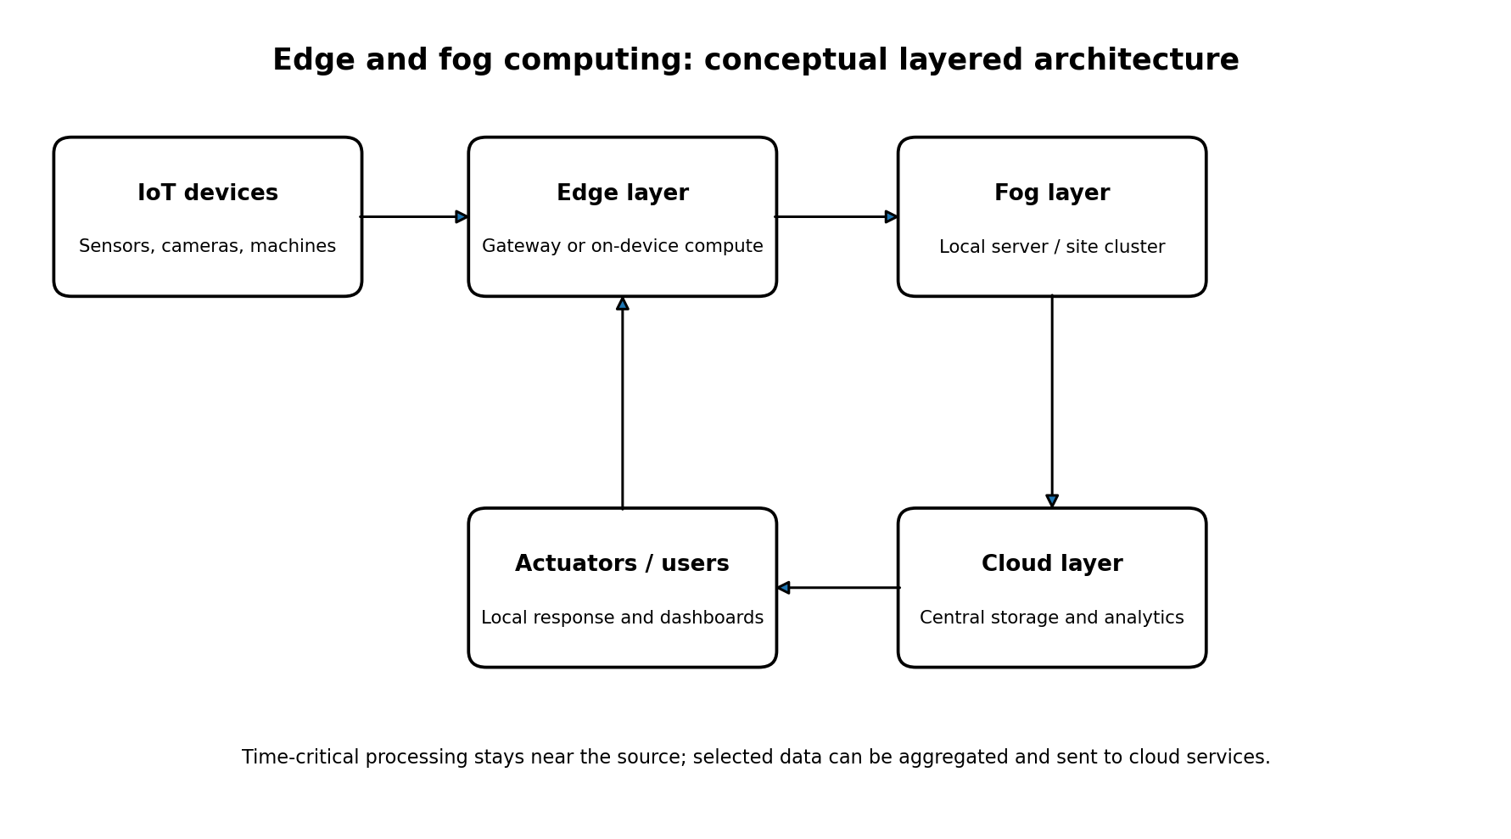
Figure 1: Conceptual layered architecture showing data moving from IoT devices through edge and fog layers to cloud services, with local response paths.

6. Case Study: Smart Factory Predictive Maintenance

6.1 Background and problem statement
A hypothetical manufacturing plant operates several motors, pumps, and conveyor belts. Sensors collect vibration, temperature, current, and operating-speed readings. Equipment faults can cause production downtime or create safety risks. Uploading every raw reading to the cloud before making a decision may be too slow or may fail during a network outage. The plant therefore needs a design that can identify urgent conditions locally while preserving enough data for longer-term analysis.

6.2 Proposed solution
The proposed solution uses a three-layer design. Edge devices attached to each machine perform basic validation, filtering, threshold checks, and anomaly scoring. A factory fog node receives events and summaries from many edge devices, correlates them across the site, manages local dashboards and alert routing, and temporarily buffers data if the internet connection is unavailable. The cloud stores historical data, compares performance across sites, and supports maintenance planning and analytics.

6.3 Workflow
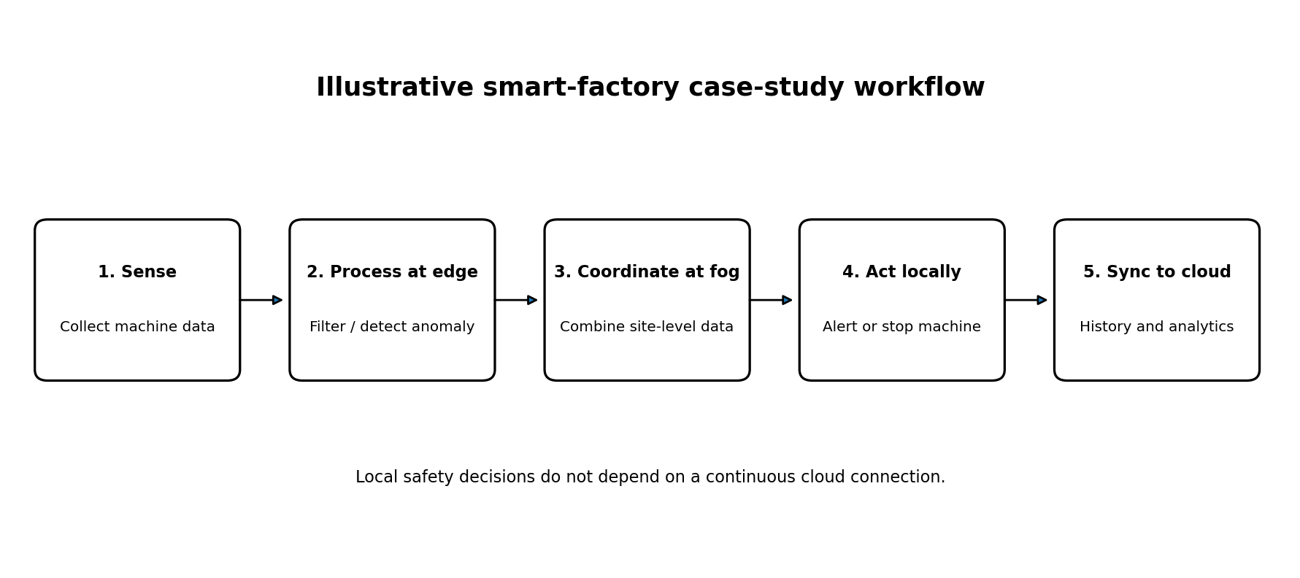
Figure 2: Illustrative smart-factory data and decision workflow.
- Sensors collect vibration, temperature, and current readings.
- The edge device validates readings and checks for abnormal values or patterns.
- When a local rule is triggered, the edge system sends an alert to the machine operator or approved control system.
- The fog node aggregates events from multiple machines, checks site-level patterns, and coordinates maintenance notifications.
- Summaries and selected diagnostic data are synchronized to the cloud for history, reporting, and model improvement.
- If the cloud connection fails, edge safety logic continues and the fog node buffers data within its available storage.

6.4 Example decision policy
Condition | Processing layer | Example action
Reading exceeds a validated machine safety threshold | Edge | Trigger a local alarm or a pre-approved safe response
Repeated anomalies across one machine over time | Edge + fog | Create a maintenance alert and attach recent diagnostic history
Several machines show correlated abnormal behavior | Fog | Notify site maintenance and investigate a shared cause
Weekly performance trends across multiple plants | Cloud | Compare asset performance and plan maintenance
These examples are conceptual. Real thresholds and machine-control actions must be defined and validated by qualified industrial and safety engineers. A general-purpose cloud or AI component must not replace certified safety controls.

7. Edge Computing vs Fog Computing
Aspect | Edge computing | Fog computing
Location | On or very near the data-producing device | Intermediate local network or site layer
Primary role | Fast, device-level processing and response | Aggregation and coordination across nearby devices
Typical resources | Sensors, PLCs, cameras, industrial PCs, gateways | Industrial gateways, local servers, site clusters
Latency | Often lowest for device-local decisions | Low, but generally involves an extra local network hop
Data handling | Filters or analyzes individual streams | Combines multiple streams and manages local buffering
Connectivity dependence | Can continue local tasks without cloud access if designed to do so | Can coordinate local services and buffer data during WAN interruptions
Limitation | Limited compute, storage, and device-management capacity | More infrastructure and operational complexity than device-only processing

8. Benefits of the proposed design
- Lower response delay for time-critical events because decisions are made near machines.
- Reduced bandwidth usage by sending summaries and relevant events instead of every raw reading.
- Improved resilience during temporary cloud or internet outages when local logic and buffering are configured.
- Better site-level awareness by correlating readings from multiple devices.
- Centralized historical analytics and fleet-level reporting remain available through the cloud.

9. Challenges and risks
- Distributed devices increase the number of systems that must be secured, patched, monitored, and inventoried.
- Different vendors and protocols may complicate integration.
- Fog nodes can become bottlenecks or single points of failure unless designed with suitable redundancy.
- Local storage is finite; buffering policies must define what to retain and what to discard during long outages.
- Model drift, noisy sensors, or incorrect thresholds can create false alarms or missed detections.
- Industrial control decisions require deterministic behavior, fail-safe design, and safety validation.
- Data synchronization and clock alignment are important when combining readings from multiple devices.

10. Security and Privacy Considerations
- Authenticate devices and services; use unique identities rather than shared default credentials.
- Encrypt communications between devices, fog nodes, and cloud endpoints where supported.
- Segment operational technology networks from general office networks and restrict inbound access.
- Apply least privilege, signed updates, secure boot where available, and a patch-management process.
- Store only necessary data and define retention and access policies for operational records.
- Log configuration changes and security events; monitor device health and certificate expiry.
- Plan recovery procedures for compromised devices, fog-node failures, and lost connectivity.

11. Evaluation Plan
Because this case study is a proposed design rather than a live deployment, no performance results are claimed. A pilot should compare the edge–fog design with a cloud-only baseline using the same workload.
Metric | How to measure | Expected direction (hypothesis)
Event response latency | Time from sensor event to local alert/action | Lower for local edge decisions
Bandwidth consumption | Bytes sent over the WAN per hour or per event | Lower when data is filtered and aggregated
Availability during WAN outage | Whether local alerts and buffering continue | Improved if local dependencies are available
Detection quality | Precision, recall, false alarm rate against labeled events | Must meet the application's acceptance criteria
Recovery and data loss | Buffered data recovered after reconnection | Within defined recovery and retention objectives
Operational cost | Device, fog, cloud, network, and maintenance costs | Evaluate total cost; savings are not guaranteed

12. Implementation Roadmap
- Identify the equipment, sensor signals, latency targets, and safety requirements.
- Select edge hardware and define local data validation and event rules.
- Deploy a fog node for aggregation, local alert routing, and store-and-forward buffering.
- Connect the fog layer to cloud storage and analytics using authenticated encrypted channels.
- Test normal operation, network loss, node failure, sensor faults, and recovery behavior.
- Run a controlled pilot, measure the evaluation metrics, review security, and expand only after acceptance criteria are met.

13. Result
The case study develops a conceptual edge–fog–cloud architecture for smart-factory predictive maintenance. It assigns urgent device-level processing to the edge, site-wide aggregation and coordination to the fog layer, and long-term analytics to the cloud. The design identifies benefits, limitations, security controls, and measurable criteria for a future pilot. It is a study and proposed design; it is not a report of a completed physical deployment.

14. Conclusion
Edge and fog computing complement cloud computing by distributing processing closer to the data source. In the smart-factory case, edge processing can support rapid local detection, fog computing can coordinate events across the site, and cloud services can provide historical analysis and centralized management. The approach can reduce latency and network traffic, but success depends on secure device management, reliable local behavior, clear failure handling, and measured validation.

15. Viva Questions
What is edge computing? Processing data on or near the device that generates it.
What is fog computing? A distributed layer of compute, storage, and networking between edge devices and the cloud.
How do edge and fog computing differ? Edge is closest to the source; fog commonly coordinates and aggregates across nearby edge devices.
Why not send every reading directly to the cloud? It can increase latency and bandwidth use and can make local response dependent on connectivity.
What is a fog node? An intermediate device or server that provides local processing and coordination.
Give one edge-computing example. A machine controller detecting an over-temperature condition locally.
Give one fog-computing example. A factory server correlating alerts from multiple machines.
What happens during an internet outage? Local functions may continue if designed for offline operation; buffered data can be synchronized later.
Name two challenges. Security and device management; also integration, finite storage, and fault handling.
Does this report contain measured results? No. It proposes a case-study architecture and an evaluation plan; real results require a pilot.

16. References
- NIST, Fog Computing Conceptual Model, NIST Special Publication 500-325: https://doi.org/10.6028/NIST.SP.500-325
- NIST, The NIST Definition of Fog Computing: https://www.nist.gov/publications/fog-computing-conceptual-model
- OpenFog Consortium, OpenFog Reference Architecture (background on fog computing concepts).
- Cloudflare Learning Center, What is edge computing? https://www.cloudflare.com/learning/serverless/glossary/what-is-edge-computing/

